CIL REPORT
Town or Parish Council: Great Glemham
1 April 2021 to 31 March 2022

A | Total CIL income carried over from previous years | £0.00
B | Total CIL income received (receipts) | £77.68
C | Total CIL spent (expenditure) | £77.68
 | Total CIL requested to be repaid in the year | £0.00
 | Total value of CIL receipts subject to a Repayment Notice served in any year that has not been repaid | £0.00
D | Total CIL repaid in the year following a Repayment Notice | £0.00
E | Total CIL retained at year end (A+B-C-D) | £0.00

CIL Expenditure
Items to which CIL has been applied: | Amount spent £
Siting of a new bench in the village | £77.68
Total spent | £77.68

Signed: 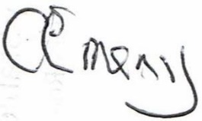 Position: Parish Clerk and Responsible Financial Officer

Verified: Position John Cross, Vice Chair of GGPC

